**6. What is Helm**

**Package manager**

* if you have installed software on any operating system, then you already know what a packaging manager.
* on Windows. We have the Windows installers, on Linux we have apt yum and if you have worked with Nodejs applications, then you know, npm the node packaging manager.
* All these packaging managers will take the package. We want to install or the software we want to install as a parameter, and they will do the installation for us. Not only that, they can even upgrade that software to the latest version as the versions come in. and if we want to uninstall that package, at some point, we can do that. Using this packaging managers
* Helm is one such packaging manager for the world of Kubernetes.

**Helm working**

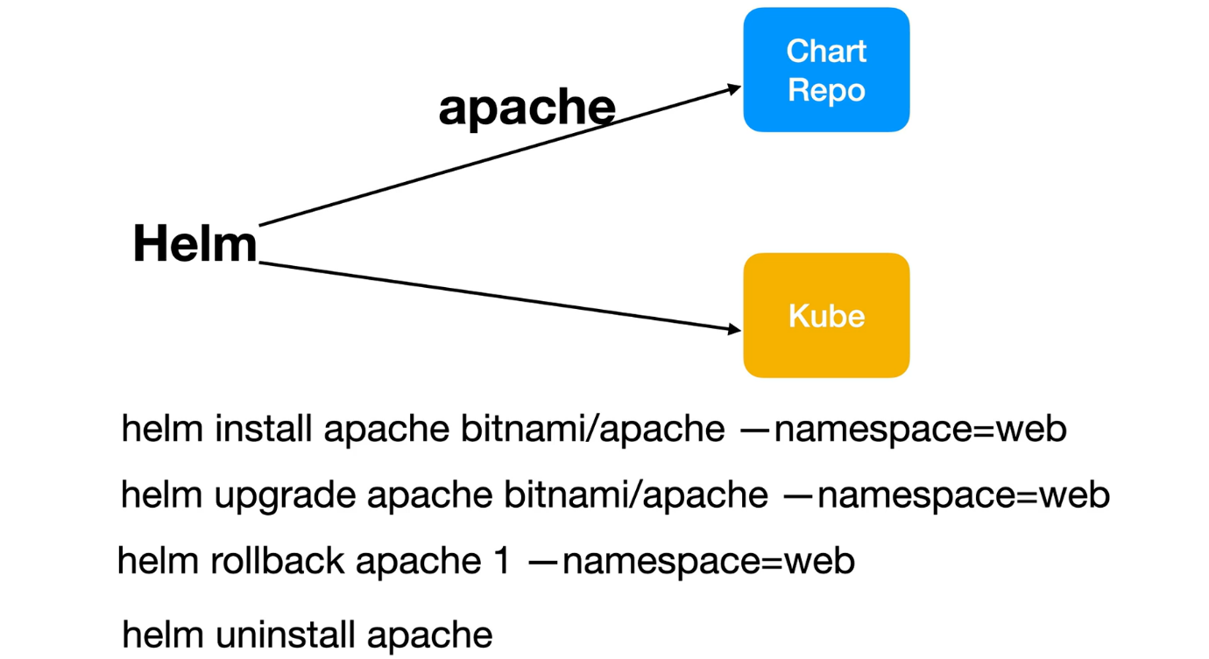

Helm works with charts. charts are like packages in the world of helm.

These charts will have all the template files and the configuration required to create Kubernetes resources. You can use a single command to pull the chart you want, for example, if you want to install Apache onto Kubernetes cluster, here is the command

**# Install apache form Bitnami repo**

--- **helm install apache Bitnami/apache -namespace=web**

--- **Apache** – name of the release

--- **Bitnami/apache** – points to the Bitnami repository on the internet.

**# Upgrade apache**

--- helm upgrade apache bitnami/apache -namespace=web

**# Rollback apache**

--- helm rollback apapche1 -namespace-web

**# Uninstall apache**

--- helm uninstall apache